2.69: a) 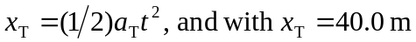, solving for the time gives 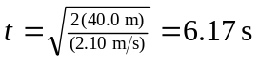
b) The car has moved a distance
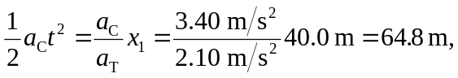

and so the truck was initially 24.8 m in front of the car.

c) The speeds are 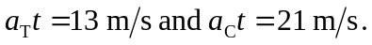

d)
